Renju lesson on November 23, 2000

Hello all! Welcome to Online Renju Class.
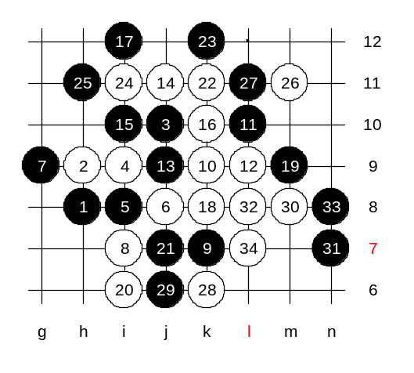
Today we will learn about another 5th move in d3 opening. Those who regularly attend the lessons know the possible 5th moves. Therefore, I let you choose which 5th move you want to learn today. Ok, you chose i8. Some words about 5-i8: This move has been the second popular 5th move after 5-g9. Over thousand games can be found in database records with this 5th move. There is no sure evaluation for this 5th move, sometimes black wins, sometimes white wins. Recently I have played it as black in tournaments. As you know, I used this move in the first game of the match with Nakamura. I lost that game. :) What choices does white have for the 6th move? Yes, g9 and j8 are the most common moves. I have also seen 6-j9 but it is seldom used. It is up to you which 6 we play first. OK, j8 first. I played these moves as black against Makarov in last WC. White uses natural idea - try to give pressure to 3x3 point. By the 14th move white attack looks promising. Point k10 is forbidden for black and white is going to win in few moves. What should black do about it? If you were black, how would you come out from this situation? Most of you said i10, so lets try it first. There are 18 moves on the board and white attack is getting stronger. Can black defend here or is it already white sure win? Black cannot play to m8 because white will play n9 and win. Move m9 might be better. M10 is too passive, white can easily develop towards lower side space. So, lets try m9. Can white win? I found it. Its pretty tricky and requires precise sequence of moves. Lets test if I am wrong. As you can see, only a precise sequence can give win here.
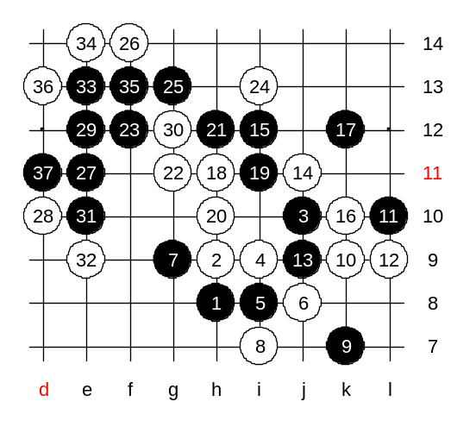

We realized that 15-i10 was bad and white could develop very strong attack there. What else can black do instead of i10? OK, you choose i12 this time. In fact, this is the move i played against Makarov. According to my analysis, there is no good continuation for white. Black gets very good position in both upper and left side.
Traditionally we test one path. So, please select white move for test. Lets use k10 then as it was suggested by most of you. Black wins by the 37th move. As you can see, black is very powerful here. That is why I used this 9th move against Makarov.
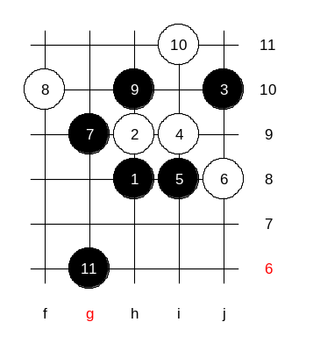

White may try another 8th move. But black is very strong here too. In fact, black can win here for sure. Regular students may notice similar position with i1 opening. You can find the same position in previous lesson files.

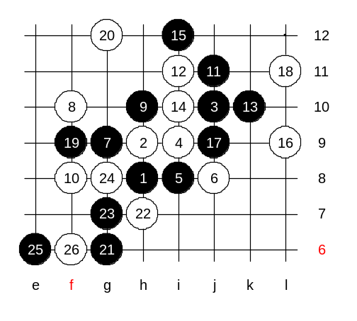
Another 8th move.
Move 9-j11 is the beginning of beautiful black winning development. Please write down this position, this is the advanced level homework. Find the black winning development here together with all branches.

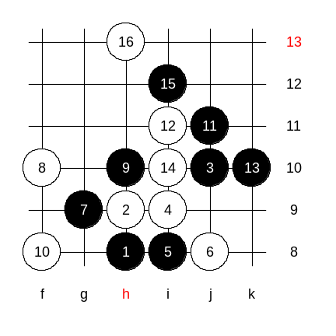

Medium level homework will be easy one. Write it down. You have to find black win here. The lesson is over. Thank you all for joining and see you again next week.

